**Leilaini**

**E-commerce Final Project**

Rhodalyn N. Nettey

CS442: E-commerce

Ashesi University

Cohort A

Mr. David Amartey Sampah

December 2, 2022

Business Plan

**Value Proposition**

Leilani seeks to take the stress and confusion off our customers when it comes to interior décor of homes, offices, and other spaces. We provide our customers with interior décor products that they can purchase from the comfort of their homes as well as links to interior designers to help bring to life their creative interior décor ideas.

**Revenue Model**

The primary source of revenue for the business will from the sale of our products and the transaction fee.

**Main Competitors**

Our main competitors include Casa Trasaco, Design Express, Silwet Interiors, to name a few. These companies have nationwide recognition and a wide range of products for interior décor.

**Market Strategy**

Our target market will constitute people who are looking to design their homes, offices, and other spaces in Accra, Ghana. The site will be user-friendly and customer oriented, as such a customer-based marketing strategy will be used. The business will make use of three of the four P’s, that is, the product, price, and promotion. The products that will be available on the platform will be of the best quality and customer reviews will be posted in order for our customers to trust the brand. The subscription price will be customer friendly. For promotion, we would have ads on other websites and also through word of mouth.

**Organizational Structure**

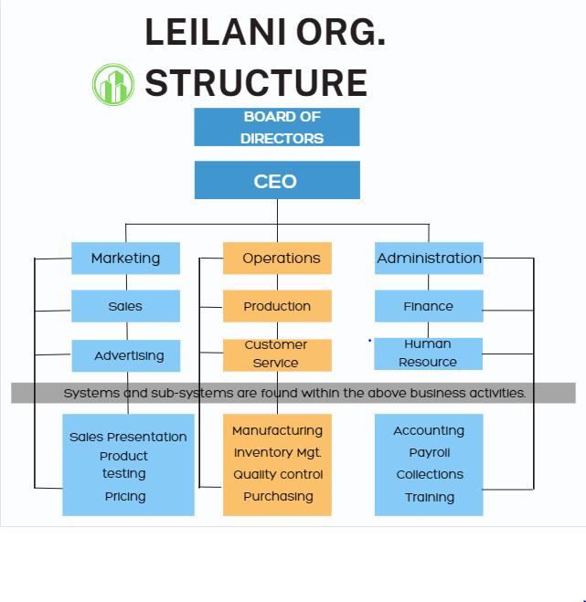

**Management Team**

Chief Executive Officer (CEO): Rhodalyn Nettey

Chief Financial Officer (CFO): Adjeley Rose

Chief Operations Officer (COO): Amara Garbin

Architectural/Product Visualizer: Romeo Nettey

**SDLC**

**System analysis and planning**

|  |  |  |
| --- | --- | --- |
| Business Objectives | System Functionality | Information Requirements |
| Display products | Digital catalog | Dynamic text and graphics catalog |
| Provide product Information | Product database | Product description, inventory levels |
| Execute transaction | Shopping cart/payment system | Multiple payment options |
| Accumulate customer information | Customer database | Name, address, email, phone; online customer registration |
|  |  |  |

**Systems Design**

In this phase, we'll build a real-world replica of our design. All outlined requirements for the system will be met by this model. Utilizing the Figma program, we will create the user interface and list the necessary procedures, inputs, and outputs. At this stage, the application architecture will also be decided. The physical layout of this design will include the main page, the registration form, and the payment portal. We will go through various design iterations and choose the interface that is both the most interactive and user-friendly.

**Systems Building**

Requirements of the system include:

Database: Storing product information and payment information and it will be used as a reference point.

Sign up/Login: For users to create accounts.

Home Page: Provides access to the products for interior décor, interior designers, and payment portal.

Payment portal: Payment will be facilitated through Paybox.

**Systems Testing**

This stage will guarantee that our website functions in accordance with user expectations. System integration testing, which examines how well the software communicates with other software programs, will be a part of it. In order to make sure that the website is of high quality and satisfies their needs, we will also conduct a manual test with a small sample of people. To give our users a better user experience, these manual checks will be augmented with frequent updates.

**Systems Implementation**

This refers to the web server configuration that will allow the website to be accessed by a larger audience.

CEO’s Signature: R.N.N.N

Github Link: <https://github.com/Rhodalynn/Rhodalyn_Nettey_Leilani>

Google One Drive link (YouTube video): https://drive.google.com/drive/folders/1a3QJpDLjYsafF3c2gHDmVrvXzN3ZHIJS?usp=sharing